

**Kidston Solar Project Phase 1**



***A CASE STUDY OF THE PROJECT MANAGEMENT LIFECYCLE***

***(GENG5505 Project Management and Engineering Practice)***

***Tuesday 3PM- GROUP 4***

Nick Duplex 22967258

Ken Ji 21671765

Ninu Latheesh 23804552

Mick Luu 22970102

Tatenda Makova 23072009

Pritam Suwal Shrestha 23771397

Rachel Tausem 23071639

Table of Contents

4

1. EXECUTIVE SUMMARY 4

2. SECTION A: CASE STUDY WRITING 5

2.1 PROJECT OVERVIEW 5

2.2 SCOPE 5

2.3 TIME 6

2.4 QUALITY 6

2.5 RISK 7

2.6 STAKEHOLDERS AND COMMUNICATION 7

2.7 COST 8

2.8 TRIPLE BOTTOM LINE (TBL) 9

**2.8.1 SOCIAL** 9

**2.8.2 ECONOMIC** 9

**2.8.3 ENVIRONMENTAL** 10

3. SECTION B: CASE STUDY ANALYSIS 10

3.1 INTRODUCTION TO PROJECT MANAGEMENT LIFECYCLE 10

3.2 CONCEPTUALISATION STAGE 11

**3.2.1 SCOPE MANAGEMENT** 11

**3.2.2 STAKEHOLDER AND COMMUNICATION MANAGEMENT** 11

**3.2.3 COST MANAGEMENT** 12

3.3 PLANNING STAGE 12

**3.3.1 RISK MANAGEMENT** 12

**3.3.2 COST MANAGEMENT** 13

**3.3.3 TIME MANAGEMENT** 13

***3.3*.4. QUALITY MANAGEMENT** 14

3.4 EXECUTION STAGE 15

**3.4.1 TIME MANAGEMENT** 15

**3.4.2 STAKEHOLDERS / COMMUNICATION / HR MANAGEMENT** 16

**3.4.3 QUALITY MANAGEMENT** 17

3.5 FINALISATION STAGE 17

**3.5.1 STAKEHOLDER MANAGEMENT** 17

**3.5.2 COST MANAGEMENT** 18

3.6 TRIPLE BOTTOM LINE 18

**3.6.1 SOCIAL** 18

**3.6.2 ECONOMIC** 18

**3.6.3 ENVIRONMENTAL** 18

4. SECTION C: RECOMMENDATIONS TO THE CASE 19

4.1 TIME MANAGEMENT 19

4.2 SCOPE MANAGEMENT 20

4.3 RISK & COST MANAGEMENT 20

4.4 STAKEHOLDER MANAGEMENT 23

4.5 COMMUNICATION MANAGEMENT 24

4.6 QUALITY MANAGEMENT 25

5. CONCLUSION 26

6. REFERENCES 27

7. APPENDIX 31

8. MEETING MINUTES & TEAM REFLECTIONS 36

# EXECUTIVE SUMMARY

The Kidston Solar Project Phase 1 (KS1) was a large-scale solar project run by Genex Power. Located in North Queensland, KS1 aimed to maximise solar energy capture and was estimated to generate 50MW of electricity annually.

In the conceptualisation stage, scope management established clear objectives which feature the installation of 1.5 million solar panels, along with the establishment of electrical infrastructure. Stakeholder engagement secured crucial approvals and partnerships with ARENA, the Queensland State Government, Société Générale and Clean Energy Finance Corporation, UGL, AECOM, Ergon Energy and Genex Australia shareholders to name a few. During planning, Genex transferred construction and finalisation risks to UGL by paying a margin fee. Power purchase agreements were established with Origin Energy and Energy Australia. Cost management efforts negotiated contracts and addressed unforeseen expenses. Time management utilised Gantt charts but lacked detailed activity descriptions. Quality management included site selection which had one of the highest solar radiation zones in the country. During execution, time management faced challenges with project financing delays, requiring adjustments to the timeline. Stakeholder communication remained transparent, evidenced by ASX announcements. Quality management provided compliance with ISO 9001 management guidelines. During project finalisation, stakeholder management extended to operations and maintenance, ensuring regulatory compliance and market participation. Cost management involved forecasting O&M costs and projected revenues.

Genex showed a commitment to the TBL during KS1’s lifecycle. Socially, it created 170 jobs during the construction stage with diverse representation. Economically, KS1 generated $13.3 million in net revenue in the first financial year after completion. Environmentally, KS1 offsets 120,000 tonnes of CO2 annually. Recommendations regarding project management for KS1 include enhancing time management by improving estimation techniques and formalising scope change processes. Strengthening risk and cost management involves sophisticated hedging mechanisms and early engagement with grid operators. Stakeholder management can benefit from structured engagement and refined contract scopes. Communication management suggests kick-off meetings and continuous reporting, while quality management emphasises thorough site assessment and grid connection procedures.

# **2. SECTION A: CASE STUDY WRITING**

## **2.1 PROJECT OVERVIEW**

The Kidston Solar Project Phase 1 (KS1) is a large-scale solar farm initiated and managed by Genex Power aimed at contributing significantly to Australia's renewable energy capacity and as a way to diversify Genex Power’s project portfolio. They initially looked to construct a pumped hydro renewable project however it proved to be harder than estimated. Without a diverse portfolio, if the pumped hydro was not successful, shareholders would not be supportive of future projects. According to Ben Guo (a non-executive Director at Genex), with the push for solar projects by the government and ARENA, Genex saw the opportunity to use the land secured for the pumped hydro project that was already in progress (B. Guo, personal communication, April 5, 2024). By harnessing advanced solar photovoltaic technology equipped with tracking systems, the project aims to optimize solar energy capture, thereby enhancing the stability and reliability of the electricity grid on both local and national scales (Genex, 2016).

## **2.2 SCOPE**

KS1 had an ambitious scope, estimated to generate 50MW of electricity annually, sufficient to power approximately 26,500 homes and will help reduce greenhouse gas emissions by around 100,000 tonnes of CO2 each year.

The project tasks encompass work across several key areas. Design and engineering efforts were concentrated on developing detailed plans for the solar farm's layout, structure, and electrical systems to ensure optimal performance and efficiency. The procurement phase was crucial, involving the sourcing and acquisition of all equipment and components essential for the construction and subsequent operational phases of the solar farm. Construction activities were focused on on-site preparation, the installation of solar panels along with their tracking systems, and the setup of critical infrastructure required for the farm’s operation.

The project’s primary components feature the installation of approximately 1.5 million solar panels, along with the establishment of electrical infrastructure—including inverters, transformers, and substations.

Following construction, a rigorous commissioning process was carried out to perform extensive testing and validation of all components, ensuring their correct function and compliance with all relevant safety and regulatory standards. To maintain the solar farm's performance and reliability, operation and maintenance protocols will be implemented, including regular inspections, cleaning, and necessary repairs.

## **2.3 TIME**

To complete a project in a timely manner acceptable to stakeholders, it is important that a comprehensive schedule management plan is implemented in the planning stage of the project. This is achieved through defining the activities and their sequencing, estimating activity durations and creating the baseline and actual plan (Hartley 2018, p.172). Genex carried out and presented this stage through the implementation of a Gantt chart outlining the life of the project (see Appendix A).

In the execution stage of the project, effective time management is required to control delays and unforeseen circumstances such as potential scope changes. These events such as the delay in Project Finance and Commissioning in the KS1 can ultimately lead to changes in the initial deadlines or prolonging the project (B. Guo, personal interview, 5 April, 2024). Genex utilised the prescribed plan from the planning stage while using the time management technique of lead time to handle unforeseen financing delays during execution. Overall, the project was completed and finalised 1 year after the planned date due to the unexpected delays in the commissioning stage (Genex Power, 2018).

## **2.4 QUALITY**

Quality management serves as a cornerstone of project management, ensuring that every facet of the solar infrastructure aligns with or surpasses industry standards and regulatory mandates. The project stakeholders employed multifaceted approaches to optimise solar power generation, transmission, and storage over its lifespan.

## **2.5 RISK**

Risk is an inevitable aspect of any project. Identifying and managing all risks throughout every stage of the project lifecycle is of paramount importance because it provides opportunities to mitigate them.

The initial risk assessment encompassed the environmental and social considerations of the project, including potential objections from local landowners and biodiversity concerns. Due to the project's location on an abandoned mine site, such issues were minimal (B. Guo, personal interview, 5 April 2024).

Genex sourced essential equipment from international suppliers like First Solar (US), SMA (Germany), and NEXTracker (US). However, international procurement introduced additional considerations for project financing, chiefly due to foreign exchange financial risk.

**"This was the first wave of large-scale projects, so, no one’s really had a lot of experience with solar at that point.”** (B. Guo, personal interview, 5 April 2024). Inexperienced teams meant the whole project was prone to making errors, creating high-risk due to the uncertainty surrounding costs and the lack of historical data on similar projects.

Moreover, grid connection providers are often government entities (Ergon Energy in this case, a QLD government owned corporation) and as such, issues of price and time of connection are often non-negotiable and connecting to the grid emerged as the longest and riskiest part of the project (B. Guo, personal interview, 5 April 2024).

## **2.6 STAKEHOLDERS AND COMMUNICATION**

Some of the major stakeholders that highly influenced the project and its requirements are the project partners which include:

* **Australia Renewable Energy Agency (ARENA)**: Project sponsor
* **Queensland State Government**: Offtake Partner

Kidston Solar will be a major contributor to the Queensland Energy Market and as such the state government has interest to support and see its successful implementation. In line with this, the QLD government signed a 20-year support deed with Genex which guarantees a price of $88/kW.

* Société Générale (an international commercial investment bank) and Clean Energy Finance Corporation (a specialised Australian bank established to promote the growth of renewables in Australia): Both firms supplied majority of the debt funding for the project.
* UGL: EPC (Engineering, Procurement and Construction) as well as Operations and Maintenance contractor.
* AECOM: Owner’s Engineer and Technical Advisor
* Coronium Pty Limited: Specialist Solar PV Consultant
* Ergon Energy: Distribution Connection
* Genex Australia Shareholders

(Genex Power, 2016)

Other external stakeholders also had to be considered. The project site is remote and so there was no need to consider the disturbance of local communities or residences, however, liaising was necessary with the indigenous Ewamian people who held native title over the land. The Australian public including those employed by Genex for construction and operations, but also those residing in Queensland/Australia as a whole can be considered stakeholders for this project as any funding Genex received from ARENA comes from the tax-payer, and it will be the Australian public who will be using the power service provided by KS1. By extension, future generations of Australians are indirect stakeholders that must be considered also, and managerial choices must reflect the commitment to the sustainable practices that Genex advertises and publicly supports.

Please note: This section is not an exhaustive description and only defines the most relevant stakeholders for discussion.

## **2.7 COST**

The establishment of a cost management plan also remains a crucial aspect in providing a clear framework regarding all “cost estimation, budgeting and cost-controlling processes” that are necessary for the stakeholder's expectations to align (Hartley 2018, p. 208).

The project cost totalled $130.65 million AUS by finalisation in 2017, roughly $40 million above the early initial theorised cost, but only $3.5 million over the later revised budget of $126 million (ARENA, 2024). Roughly 6.77% of this was provided by ARENA in the form of a $8.85 million grant, 13.23% was sourced via equity through issuing of new shares by Genex, and the remaining 80% of the project funding was taken on as debt financing supplied by Societe General and Clean Energy Finance (Genex/ARENA, 2017) Though the project’s secure cash inflows guaranteed by the QLD government upon completion could’ve have warranted a higher level of leverage to be taken on, 80% of the total costs was total percentage these banks would offer as they required the company to have some ‘skin in the game’ in terms of equity from its investors (Genex/ARENA, 2017).

## **2.8 TRIPLE BOTTOM LINE (TBL)**

Genex Power was able to implement a sustainable project management approach through their commitment to the TBL. The inclusion of social, economic and environmental opportunities in KS1 highlights their dedication to sustainability.

### **2.8.1 SOCIAL**

The successful completion of the project demonstrates the support that exists for, and promotes the financial viability of, renewable energy projects in Australia to other industry leaders. This contributes to the shift of the Australian energy sector towards renewables. The project also provided much needed jobs in the area. As an equal opportunity employer, job creation in local communities is a core focus at Genex Power. During the construction phase, 170 jobs were created with 35% of workers female and 15% indigenous (Genex Power, 2021).

### **2.8.2 ECONOMIC**

KS1 utilises an existing 132kV transmission line connected to the National Electricity Market (NEM), enabling power generation for up to 26,000 households (Genex Power, n.d.). This increase in power generation will stabilise the electricity network in Northern Queensland by reducing the need to import excess electricity from neighbouring areas (ARENA, n.d.).

The location of the KS1 project provided a much-needed economic boost to a depressed region in North Queensland (Genex Power, 2021). As of November 30th, 2021 (ARENA, n.d.), it generated $13.3 million in net revenue across the 2021 financial year (Genex Power, 2021).

### **2.8.3 ENVIRONMENTAL**

KS1 directly increased the total renewable energy generation in Queensland by 6% (ARENA, n.d.) whilst offsetting 120,000 tonnes of carbon dioxide emissions per annum (Bloch, 2017). In addition, there are minimal environmental issues as the solar farm is built on the abandoned Kidston gold mine meaning the land was already disturbed an therefore primed for reuse. Furthermore, there is ample water supply from the Kidston Dam which was used for construction and operation of the solar farm (Genex Power, 2015).

# **3. SECTION B: CASE STUDY ANALYSIS**

## **3.1 INTRODUCTION TO PROJECT MANAGEMENT LIFECYCLE**

The project management lifecycle is a series of stages that a project goes through from its initiation to completion of the project. It can be divided into four stages including:

1. **Conceptualisation Stage** - The initial stage of the project where the concept is generated. This involves discussing initial objectives, expected outcomes, and alignment with the overall strategic vision. Challenges and advantages are identified, and an assessment is made regarding their potential impact using TBL and life cycle analysis. (Faiello, 2024)
2. **Planning Stage** – Tasks are planned and scheduled. Objectives are solidified, resources are allocated, and quality standards, including those related to TBL and life cycle considerations, are confirmed. Final costs are authorized, timelines are agreed upon, and all other administrative details are resolved. (Faiello, 2024)
3. **Execution Stage** – Project has commenced, and emphasis is on tracking actual progress using the schedules developed in Planning Stage as the comparison point of reference. All work including TBL & Life Cycle thinking is monitored, controlled & corrected where necessary with schedules being reviewed, revised & updated as required. (Faiello, 2024)
4. **Finalisation Stage** – Project is completed, and deliverables are transferred to the client. Utilised resources are either reallocated or appropriately disposed of. The project undergoes evaluation, with reports prepared and presented, and the administrative aspects of the project are concluded. (Faiello, 2024)

This section analyses Genex project management competencies, processes, and techniques in relation to the 4 stages.

## **3.2 CONCEPTUALISATION STAGE**

### **3.2.1 SCOPE MANAGEMENT**

The conceptualisation stage of KS1 was marked by a rigorous scope management process aimed at establishing a clear project timeline and defining deliverables, namely, an energy production capacity of 50MW annually by Q4 2017. As a part of outlining the boundary of the project, preliminary conceptual drawings of the proposed project site were produced (see Appendix B).

Scope creep was not experienced after this stage in terms of deliverables but only in timeline and cost, as will be discussed.

**3.2.2 STAKEHOLDER AND COMMUNICATION MANAGEMENT**  
Genex had sought approvals such as freehold land acquisition, development approval, and environmental approval in the concept stage. This was done through communication with the Queensland Government Department of Environment and Heritage Protection (DEHP), with all approvals being granted (Genex, 2016). Genex was able to acquire the support from ARENA under their funding agreement, the 20-year revenue guarantee from the QLD state government and an agreement with Ergon Energy for the use of their substation nearby the project site.

Following this, Genex arranged the debt funding agreements with Societe Generale and Clean Energy Finance, as well as appointing AECOM and UGL for the roles of owner’s engineer and preferred EPC & O&M contractor respectively (Technology, 2021).

A stakeholder power interest matrix outlining the key stakeholders is displayed in Figure 1.

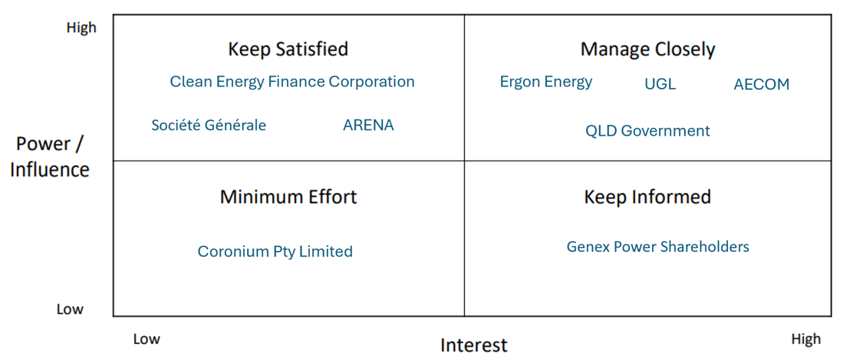

*Figure 1. Key Stakeholder Power Interest Matrix*

### **3.2.3 COST MANAGEMENT**

The Asia-Pacific Solar Research Conference compiled an analysis report for Genex on KS1, the results of which estimated the typical capital expenditure for a large-scale solar farm to be roughly $90 million (APSRC, 2016). It was also considered that the close proximity of the chosen location of KS1 to an already existing power substation would dramatically lower costs as to build any length of transmission line from a power station to a substation (for the purpose of connecting to the power grid) is very expensive and increases with each kilometre required. This was perhaps the most significant choice related to cost management throughout the entire project. (B. Guo, personal interview, 5 April 2024).

## **Risk**

### **3.3.1 RISK MANAGEMENT**

Genex paid a margin to UGL to take on all the risks associated with the construction/finalisation of the solar farm, transferring the responsibility for any potential issues or failures, such as equipment malfunctions or construction delays, to UGL (B. Guo, personal interview, 5 April 2024).

PPAs were signed with retailers like Origin Energy and Energy Australia to guarantee revenue for 10 to 20 years to assure revenue certainty in addition to the 20-year revenue support deed already received (B. Guo, personal interview, 5 April 2024). Partnering with established retailers provided the project with access to a wider market for selling its generated electricity while also enhancing market resilience.

### **3.3.2 COST MANAGEMENT**

The average price of the seven tenders offers Genex received for the primary contracts for the project was $115,000,000 however negotiated with UGL down to $102,472,000 for them to become the preferred contractor (Genex/ARENA, 2017).

Additionally, various hedging methods were used during the financing phase to manage potential costs, however unaccounted for exposure to foreign exchange risk resulted in Genex experiencing heavy foreign exchange costs. This extended the budget by the amount lost and required Genex to return to its shareholders for additional capital raising (Genex/ARENA, 2017).

These efforts saw a new revised increased budget of $126 million, an example of a bottom-up / vendor bid analysis approach to budgeting as a firm grasp on the total costs only became apparent after negotiations with contractors were complete. (B. Guo, personal interview, 5 April 2024)

### **3.3.3 TIME MANAGEMENT**

The result of Genex schedule management planning from feasibility to commissioning is presented in a Gantt chart (see Appendix A). The chart is effective in illustrating the unique identifiers of the activities, activity durations, imposed dates, the project calendar, and logical relationships in a straightforward way. It can be assumed that lead and lag time are accounted for in the planned durations of each activity.

The time durations for estimated activities were devised through a combination of multiple estimation techniques including expert judgement, group decision-making and parametric estimates (Genex Power, 2016). In addition, the duration for the construction stage was estimated using vendor bid analysis where it is relied upon the market through expression of interest, request for tender and other market invitations to accurately estimated the time for construction presented in the Gantt chart. (Hartley 2018, p.175).

However, the Gantt chart lacks meaningful description of each activity and excludes important information such as resource requirements, underlying assumptions, relevant constraints, and reference requirements.

### ***3.3*.4. QUALITY MANAGEMENT**

Genex employed two key tactics to enhance quality management:

Location Selection: The site chosen for KS1 is located roughly 270km northwest of Townsville in Northern Queensland, Australia. (Power Technology, 2021) This location boasts one of the highest solar radiation zones in the country, making it ideal for solar energy generation. (ASX, 2016) Additionally, its proximity to Townsville and Cairns, coupled with access to existing infrastructure like substations and transmission lines, facilitates efficient energy distribution. (Power Technology, 2021) (see Appendix C: Locational Advantage) Furthermore, situating the solar farm at the former mine site mitigates environmental impacts, particularly concerning the existing tailings storage facility. (Power Technology, 2021)

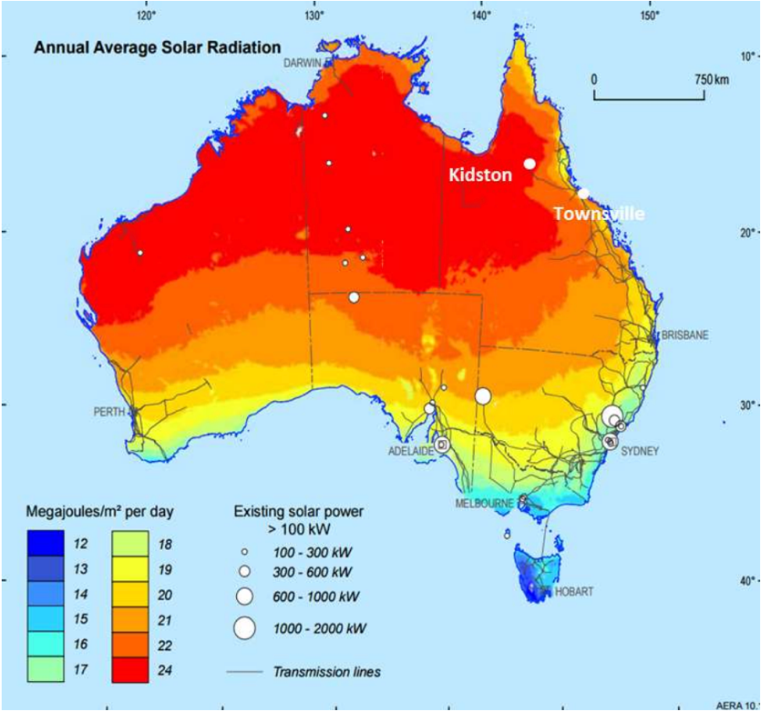

*Figure 2:Project Location - situated in one of the highest solar radiation zones in Australia (ASX)*

Collaboration with Experienced Partners: Genex collaborated with seasoned professionals to ensure the project's success. They engaged an experienced owner's engineer, AECOM, to oversee feasibility and evaluate potential contractors. (Power Technology, 2021). The strategic partnership with UGL ensured that the project benefits from the expertise and proficiency of industry leaders, enhancing its overall quality and performance.

## **3.4 EXECUTION STAGE**

### **3.4.1 TIME MANAGEMENT**

Delays in project finance activity (2-3 months after the proposed date) resulted in the original plan needing to be altered. In the original schedule the project finance and construction activities were planned to occur ‘in series’, one following the other in a finish-start relationship (see Appendix A). The company had trouble forecasting the time duration of the financing stating that ‘the specifics involved in securing renewable energy project financing is something which is difficult to foresee, particularly for project developers who had not previously completed project financing in the renewables industry’ (Genex Power, 2017), suggestive of poor activity duration estimation technique. Despite this, Genex was able to start the construction stage before financial closure by taking advantage of lead time (see Appendix A). The ‘in-series’ activities moved to an ‘in-parallel’ format with the overlap representing the lead time as shown in Figure 3.

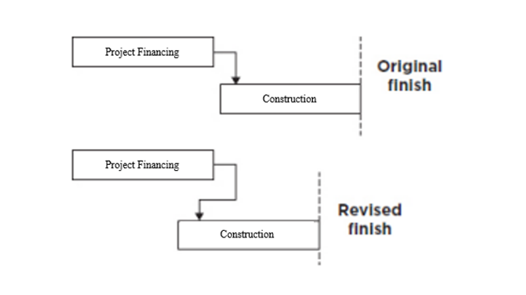

*Figure 3:Genex Lead Time/Intentional Acceleration [Adapted From (Hartley 2018, p.184)]*

Figure 4 illustrates how the revised project timeline Gantt chart with the lead time Project Financing and Construction was a more accurate timeline for those stages as it was made later.

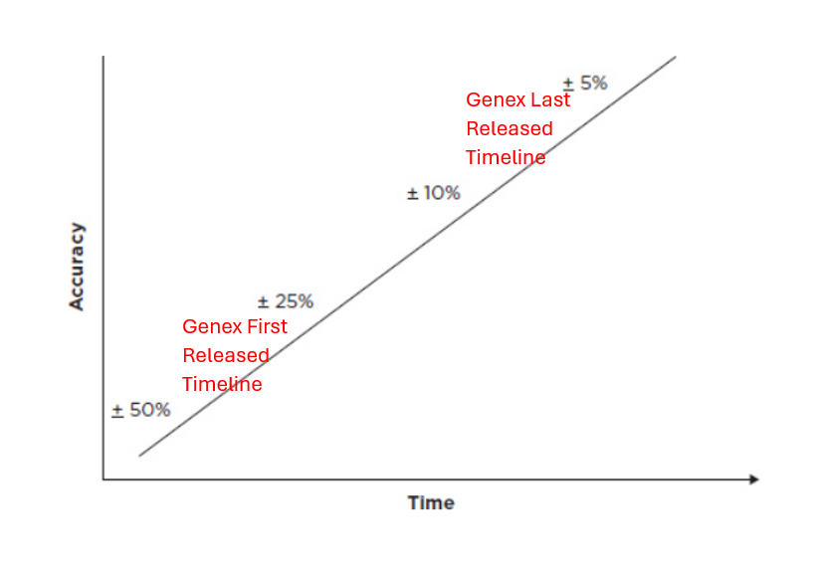

*Figure 4 Estimating Time Accuracy, [Adapted From (Hartley 2018, p.176)]*

Although the construction stage was completed on time (Genex Power 2017), unexpected delays in the commissioning stage of the project (connecting to grid) meant that the practical completion date of the project was 1 year later than planned (planned completion – Q4 2017, practical completion Q4 2018) (Genex Power, 2018).

Ben Guo said, “There was a lot of issues doing that right because back then the grid operators were still quite inexperienced in terms of connecting new renewable energy projects... You need additional equipment and whatnot” (personal interview, 5 April, 2024). This demonstrates failure to identify the task dependencies, underestimating the effort required and a lack of understanding of what is required early in the project life cycle which resulted in a delay in the finalisation of the project.

### **3.4.2 STAKEHOLDERS / COMMUNICATION / HR MANAGEMENT**

Communication between stakeholders and HR management was clear and concise in the execution stage, which is evident through the ASX announcements on every step of the ongoing construction. These reports detail the tasks completed since the last announcement with accompanying images, examples of which can be seen in Appendix D (ASX, 2017).

Following construction, delays in grid connection caused a dispute between Genex and UGL about how much of the issue was within UGL’s contractual scope and responsibilities. This was settled with a compromise between the two parties after legal negotiations resulting in UGL having to pay Genex upwards of $5 million to partially compensate for delay costs as well as legal court fees (Mr B, Guo personal interview, 5 April 2024). This is an example of a compromising strategy to deal with stakeholder pressures.

### **3.4.3 QUALITY MANAGEMENT**

Quality management tactics implemented by AECOM and UGL include:

Compliance with Standards: The EPC Contractor adheres to stringent quality assurance protocols, in line with ISO 9001 management guidelines for construction activities.(Crowley A., 2022) This includes the establishment of a comprehensive Project Quality Assurance system encompassing an overarching Quality Management Plan, Construction Execution Plans (CEPs) for major works components, Inspection and Test Plans (ITPs), and meticulous documentation of testing results and manufacturer data. A dedicated Quality Manager and Team oversee the implementation of these measures, ensuring that quality requirements are consistently met throughout the project's lifecycle. (Amy Crowley, 2022)

Utilisation of Innovative Technology: The Kidston solar farm integrates cutting-edge technology, such as First Solar's 4v3 Modules (S4-Modules), renowned for their performance and reliability in various climates worldwide. (Power Technology, 2021) These advanced thin film modules, mounted on a tracking system, optimise sunlight capture by adjusting panel angles to follow the sun's trajectory. (ARENA, 2022) This innovative design enhances the project's capacity factor, ensuring maximum electricity generation efficiency, especially in the hot and humid conditions prevalent at the Kidston site.

## **3.5 FINALISATION STAGE**

**3.5.1 STAKEHOLDER MANAGEMENT**  
From finalisation onwards, UGL’s responsibilities extend to the management of operations and maintenance of KS1 and has also worked in conjunction with Powerlink to be able to deliver a shared goal of utilising local employment. These opportunities range from waste management and recycling, access works, cleaning services, equipment and machine hiring and many more (Powerlink, 2024).

Genex also received registration for KS1 as a Market Generator by the Australian Energy Market Operator (AEMO), and thus, completed all technical and regulatory processes to enable the export of electricity into the NEM.

### **3.5.2 COST MANAGEMENT**

Financial projections after execution saw forecasted values which include (all annually): O&M costs of $1,530,000, $147,000 insurance costs, an assumed inflation of 2.5%, degradation of 0.35%, and a project IRR of 9.295% based on a lifetime of 25 years (Genex/ARENA, 2017).

## **3.6 TRIPLE BOTTOM LINE**

### **3.6.1 SOCIAL**

The rigorous procedures of identifying and obtaining the most suitable stakeholders, utilising the communication and time management methods have resulted in a project that can be viewed socially as excellent. The completion of the project with a clear and main focus on renewable energy is historical and a pioneer for the industry and socially acceptable amongst the Australian population.

### **3.6.2 ECONOMIC**

Managing cost, time and risk within this project has resulted in a project that has delivered value for its shareholders. Although, there were delays and incidents, proactive management and strong contingency allowed for the project to be one that resulted in a market capitalisation multiples of what it was before the beginning of the project.

### **3.6.3 ENVIRONMENTAL**

The effective use of scope management and quality management with clear goals (50MW output, decarbonisation energy options) identified in the conceptualisation phase and quality check/quality assurance (QA/QC) throughout the project and afterwards have led to the environmental portion of the TBL of the project being excelled.

# **4. SECTION C: RECOMMENDATIONS TO THE CASE**

## **4.1 TIME MANAGEMENT**

The estimation for the time of the Project Financing proved a big obstacle for the time management of the project. With the Financial close being reached 2-3 months after the proposed time and commissioning finishing 1 year after the planned date, it is recommended that different methods of time estimation should be utilized to avoid necessity for changes in proposed plans. The technique of expert judgement would have been useful, having the input of an expert with specialized input in capital raises to do with renewable energy and knowledge regarding the market would have helped in being able to forecast the amount of time needing to be allocated to financing (Hartley 2018, p.). In addition to this, the utilization of a three-point estimate, (a weighted average requiring the optimistic, pessimistic and most likely estimates that define an approximate range for the expected duration) (Hartley 2018, p.) would have been useful in allocating a greater amount of time to these steps of the project. The three-point estimate would have been especially useful with the existing team Genex had, given they had limited experience in this specialised type of project. Utilising a lower level of confidence would have resulted in more realistic allocation of time duration for Project Financing and Commissioning as illustrated in Figure 5 (Hartley 2018, p.).

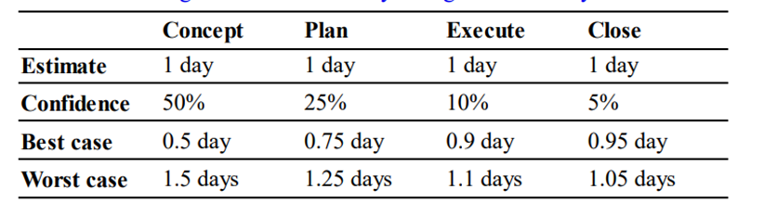

*Figure 5 Time Estimation and Confidence Illustration (Hartley 2018, p.175)*

Furthermore, a formal recording of these confidence levels being reflected in the presented Gantt chart and a focus on underlying assumptions and impacting constraints would have been useful in forecasting the potential duration of financing (Hartley 2018, p.). A greater understanding of the resource capability in terms of funding and funding would be helpful in providing a more accurate estimation of the activity duration (Hartley 2018, p.). As the project was one of the first of that type in Australia, allocating more time to researching how commissioning would work or seeking international advice could have resulted in a more accurate plan. Another recommendation could be the addition of a Work Breakdown Structure alongside the Gantt Chart, which has the advantage of breaking down each activity which provides information with more meaningful descriptions of what is involved in each activity (Faiello, 2024). This would be useful for stakeholders to understand the specific steps required to be taken in each activity for the estimated duration and may have helped in forecasting the issues that came up in the finalisation stage.

## **4.2 SCOPE MANAGEMENT**

* Strengthen Stakeholder Engagement: Implement a structured approach to stakeholder management that ensures continuous and open communication. This can help manage expectations and facilitate smoother scope adjustments when necessary.
* Scope Baseline Review and Adjustment Process: Develop a formalised process for reviewing and adjusting the scope baseline at predefined stages of the project. This process should involve key stakeholders to ensure alignment and buy-in.
* Utilise Scope Change Control Board: Establish a Scope Change Control Board comprising key project stakeholders responsible for reviewing and approving scope changes. This board should assess the impact of each change on the project's objectives, costs, and timeline.
* Invest in Training for Scope Management: Provide training for the project team on best practices in scope management, including how to manage scope creep and negotiate scope changes with stakeholders. Educating the team can lead to more effective scope control and project delivery.

## **4.3 RISK & COST MANAGEMENT**

In response to the challenges faced during the planning phase of the project, Genex Power should prioritize enhancing its risk management strategies. This involves implementing more sophisticated hedging mechanisms such as forward and futures contracts as well as closely monitoring currency fluctuations to mitigate the impact of unforeseen market volatility. Additionally, conducting a thorough review of the project's financial model and incorporating contingency plans to address currency exchange rate fluctuations are crucial steps to mitigate similar risks in future projects.

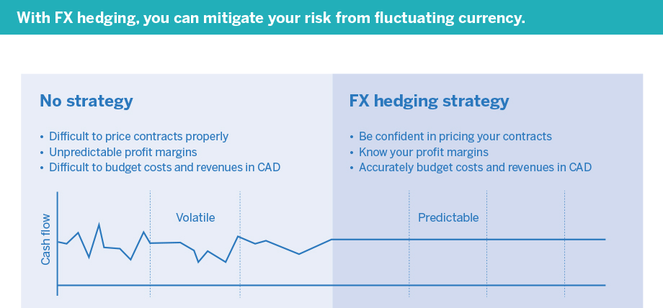

*Figure 6: Visualisation of fluctuating currency (Export Development Canada, 2021)*

Genex can also utilise a risk register as shown in Appendix E to identify potential setbacks within the project and implement controls to mitigate them which allow more certainty in formulating revised project budget and also manage the expectations of stakeholders and investors.

Many frameworks exist which may aid in the of construction a risk register and general risk analysis, with the most appropriate for KS1 being the PESTELG framework which is used more to identify the external factors that may impact a project (Faiello, 2024). The key external factors of this framework and how they related to KS1 are as follows:

**Political Factors:**

Changes in government policies, regulations, incentives, or subsidies related to renewable energy can impact the construction and operation of solar farms and financial viability of the project. Political stability and support for renewable energy initiatives can influence investor confidence in the project.

**Economic Factors:**

Economic conditions, such as interest rates and inflation, can affect the cost of financing the project as well as market demand for solar energy and electricity prices can influence the revenue generated by the solar farm.

**Social Factors:**

Environmental awareness and concerns about climate change may drive demand for renewable energy and support for solar farm development.

**Technological Factors:**

Advances in solar technology, such as improvements in photovoltaic efficiency and energy storage systems, can affect project costs and performance. Availability of skilled labour and expertise in solar farm construction and maintenance can impact project timelines and quality.

**Environmental Factors:**

Environmental regulations and permitting requirements, including land use and habitat protection, can impact site selection and project development.

Assessment of environmental impacts, such as land degradation, water use, and wildlife habitat disturbance, must be considered during the planning and design phase.

Mitigation measures for minimizing environmental risks and ensuring compliance with regulatory standards are essential for project sustainability.

**Legal Factors:**

Legal frameworks governing land rights, property ownership, and zoning regulations can affect land acquisition and project development.

Contracts and agreements with landowners, contractors, and suppliers must comply with legal requirements and address potential liabilities.

Compliance with environmental, health, and safety regulations, as well as permitting and licensing requirements, is necessary for project approval and operation.

**Global:**

Fluctuations in global economic conditions, such as recessions or economic downturns, can affect the availability of financing and investment for large-scale infrastructure projects like solar farms.

Changes in global commodity prices, currency exchange rates, and trade policies can impact the cost of materials and equipment imported for solar farm construction.

Although brief, this list demonstrates how the PESTELG framework could be applied to the risk identification and management planning for a solar farm like KS1, and a more comprehensive and detailed analysis is highly recommended. As it was unlikely that public or government support for the project wouldn’t waver, the risk associated with the Political and Social factors were quite low. However, the issues that arose concerning the Economic, Legal and Global factors during the project's lifecycle highlight how critical a framework such as PESTLEG would be to both spot and account for these risk factors early, and perhaps mitigate them entirely.

Additionally, given the criticality of grid connection, Genex should have prioritised early engagement with grid operators and regulatory authorities to streamline the process as to not be caught-out and experience delays near the end of the project. Conduct comprehensive feasibility studies beyond simply the richness of solar radiation should be incorporated to identify potential challenges and develop contingency plans to address unexpected delays or cost overruns. Allocating sufficient budget and resources to ensure timely completion of grid connection activities is equally important.

## **4.4 STAKEHOLDER MANAGEMENT**

Managing stakeholder engagement by anticipating future problems, associated risks and reactions to different situations will reduce any conflict with stakeholders when unexpected issues arise (Hartley 2018, p.130). With KS1 being a renewable project, issues with integration were bound to occur at the end of the execution stage and the start of the finalisation stage. There are two ways Genex could implement this change. Firstly, they could account for future problems by including them in the stakeholder management matrix (see Table 1 as an example).

***Table 1. Example of a Stakeholder Management Matrix to include anticipating future problems****.*

|  |  |  |  |  |  |
| --- | --- | --- | --- | --- | --- |
| Stakeholder | Responsibilities | Information required | Format | Frequency | Who |
| UGL | Fixing connection issues to the grid | * Technical performance issues * Delays * Schedule delivery | Meeting | Weekly/  Fortnightly until issue is resolved | Project Manager |

Secondly, Genex could have refined the contract scope for UGL. As mentioned, there was a contractual conflict whilst the connection to the grid was being established. This means the contract scope was vague regarding connection issues. This should be clearly included or excluded in the contract scope with a monetary value assigned to the risk associated with the issue, so both parties are aware of the expectations.

These recommendations are made to improve stakeholder satisfaction and accountability. Stakeholder satisfaction is a key indicator of successful project management. With Genex looking to diversify their renewable energy portfolio, it is imperative they maintain good relationships with stakeholders moving forward.

## **4.5 COMMUNICATION MANAGEMENT**

Regarding the communications throughout the planning stages, ways of improving such communications would be by conducting a kick-off meeting, which is the first meeting with the project team and stakeholders of the project, and by establishing a purpose and a common goal for the project. This helps solidify the purpose and outcome of the project (Atlassian, 2024). In addition, conducting continuous reporting on the project could help further strengthen the integrity of the project by assisting the management of the project status accurately and in real-time. For example, this is done by using a progress report, a status report, and a forecast report to ensure that the project is running smoothly. This can help the project team by being able to pinpoint and identify potential issues and errors of the project at each step of the project in both the planning and finalisation stages, as this creates a logbook of all the events that have occurred (PSA, 2024).   
  
Moreover, effective project control can be used in the finalisation stage of the project to ensure that the assets are performing to the standards required of them, such as monitoring and measuring the standards through regular inspections of these assets. As well as this, creating milestone charts and control charts can help construct a clear planning stage for the project, while documents such as contingency plans and change request register can be used to record and track all the changes in the project.

## **4.6 QUALITY MANAGEMENT**

Quality management in a solar farm project is paramount for ensuring efficiency, durability, and safety. “I found the largest risk is the connection risk, so that was a key learning for everyone throughout the process is to understand the connection risk and understanding the ground conditions. So those were the two things that brought a lot of the contractors unstuck. You would probably spend more attention on the grid studies grid connection studies.” (Mr B, Guo personal interview, 5 April 2024).

Ben Guo's insight emphasises the critical importance of understanding connection risks and ground conditions. To address these challenges effectively, additional recommendations for site assessment and grid connection commissioning are advised:

Thorough Site Assessment and Conducting a meticulous evaluation of the site before construction is essential. Engage geotechnical engineers to analyse soil samples, assess ground conditions, and understand local topography. This comprehensive assessment should identify potential risks like flooding or seismic activity, enabling the development of robust foundation designs tailored to site-specific conditions.

Grid Connection and Commissioning, During the final construction phase, prioritise the seamless integration of the solar farm with the external energy transmission grid. (see Appendix F: Kidston connection project - proposed future connection by AECOM) This involves connecting the central substation to the high-voltage grid, typically at 132KV or higher. (Queensland Government, 2018) Rigorous quality and safety checks must precede commissioning to ensure compliance with standards and regulations. Thorough testing and verification of connections, alongside adherence to safety protocols, are imperative to mitigate risks and ensure the reliability of the grid connection.

By implementing these two critical quality management measures, solar farm projects can effectively mitigate the risks associated with ground conditions and connection issues. This proactive approach contributes to the long-term success and optimal performance of the installation.

# **5. CONCLUSION**

The Kidston Solar Project Phase 1 (KS1) by Genex Power, has demonstrated overall success, despite encountering key challenges during its lifecycle. The completion of the project, albeit with delays, signifies a significant milestone in the company's renewable energy portfolio.

Throughout the project, several key issues emerged that impacted its success. These included the lack of experience among contractors, leading to risks in expertise and execution, financial uncertainty due to substantial costs associated with grid connection, delays in project finance and commissioning affecting the timeline, challenges in stakeholder management and communication, and risks associated with international suppliers and foreign exchange financial risk.

To address the challenges faced and improve future project outcomes, it is crucial for Genex Power to focus on key areas of improvement. Several recommendations are proposed to avoid potential issues such as enhancing contractor selection processes to ensure expertise, conducting thorough feasibility studies for grid connection challenges, and prioritizing early engagement with regulatory authorities. Additionally, implementing robust stakeholder and time management strategies, improving communication practices, and strengthening quality control measures should be prioritised.

By investing in these critical aspects, Genex Power can enhance project success, mitigate risks effectively, and foster stakeholder satisfaction and accountability for sustainable project management. Learning from past challenges and leveraging these insights will enable Genex Power to navigate future projects with greater efficiency and success in the competitive renewable energy market.

# **6. REFERENCES**

Advancing Renewables Programme Funding Agreement -large-scale solar photovoltaics -competitive round| P1 Knowledge Sharing -Submission II. (2017). [online] Genex Power, ARENA. Available at: <https://genexpower.com.au/wpcontent/uploads/2021/10/genex_power_knowledge_sharing_-_submission_ii.pdf>.

*ARENA Kidston Solar Project (Phase 1). (n.d.). Australian Renewable Energy Agency.* [*https://arena.gov.au/projects/kidston-solar-project-phase-1/*](https://arena.gov.au/projects/kidston-solar-project-phase-1/)

ARENA. (n.d.). Kidston Solar Project (Phase 1). Australian Renewable Energy Agency. https://arena.gov.au/projects/kidston-solar-project-phase-1/

*ASX Announcement TWO EPC PROPOSALS SHORTLISTED FOR KIDSTON LARGE-SCALE SOLAR PV PROJECT*. (March 2016). https://announcements.asx.com.au/asxpdf/20160302/pdf/435jjl0cpb60gz.pdf

ASX Announcement. (2016). [online] *ASX*. Genex Power. Available at: <https://cdn-api.markitdigital.com/apiman-gateway/ASX/asx-research/1.0/file/2995-01777129-2A971460>.

ASX. (2017, October 18). ASX Announcement: Kidston Solar Project (Phase one 50MW) Update. Genex Power ASX . https://cdn-api.markitdigital.com/apiman-gateway/ASX/asx-research/1.0/file/2995-01909113-2A1043504   
  
Power, G. (2016). Company Announcements Office Australian Securities Exchange Via: Electronic Lodgement GENEX FINALISES KIDSTON SOLAR PROJECT DELIVERY TEAM. https://cdn-api.markitdigital.com/apiman-gateway/ASX/asx-research/1.0/file/2995-01750692-2A956819

Crowley, A. (n.d.). *Prepared by Genex Power Limited*. <https://genexpower.com.au/wp-content/uploads/2023/06/kidston-pumped-hydro-energy-storage-construction-report.pdf>

Export Development Canada (2021) *By the numbers: Foreign Exchange (FX) hedging tools that will improve your bottom line*, *EDC*. Available at: https://www.edc.ca/en/guide/fx-hedging-infographic.html (Accessed: 01 April 2024).

Export Development Canada (2021) By the numbers: Foreign Exchange (FX) hedging tools that will improve your bottom line, EDC. Available at: https://www.edc.ca/en/guide/fx-hedging-infographic.html (Accessed: 01 April 2024).

Faiello, C. (2024). GENG5505: Project Management and Engineering Practice: Week 3b Lecture 6 14th March. [PowerPoint Slides]. <https://lms.uwa.edu.au/>

Faiello, C. (2024). GENG5505: Project Management and Engineering Practice: Week 1b Lecture 2 29th February. [PowerPoint Slides]. https://lms.uwa.edu.au/   
  
Atlassian. (2024). How to set up the perfect project kick off meeting. Atlassian. https://www.atlassian.com/work-management/project-management/project-kickoff#:~:text=A%20project%20kick%2Doff%20meeting

Genex Kidston Connection Project -Ministerial Infrastructure Designation Assessment Report 2021 Prepared for Powerlink Queensland. (n.d.). Retrieved April 14, 2024

Genex Power. (2015). Development of up to 150MW Kidston Solar Project at Kidston “Energy Hub.” ASX Announcement. Australian Securities Exchange. <https://cdn-api.markitdigital.com/apiman-gateway/ASX/asx-research/1.0/file/2995-01669949-2A883668>

Genex Power. (2016). Company Announcements Office Australian Securities Exchange Via: Electronic Lodgement GENEX FINALISES KIDSTON SOLAR PROJECT DELIVERY TEAM. https://cdn-api.markitdigital.com/apiman-gateway/ASX/asx-research/1.0/file/2995-01750692-2A956819 Genex Power. (2016). GENEX FINALISES KIDSTON SOLAR PROJECT DELIVERY TEAM. <https://cdn-api.markitdigital.com/apiman-gateway/ASX/asx-research/1.0/file/2995-01750692-2A956819>

Genex Power. (2017). 50MW KIDSTON SOLAR PROJECT REACHES PRACTICAL COMPLETION. <https://cdn-api.markitdigital.com/apiman-gateway/ASX/asx-research/1.0/file/2995-02055600-2A1121405>

Genex Power. (2017). GENEX ACHIEVES FIRST ENERGISATION FOR KIDSTON SOLAR STAGE 1. <https://cdn-api.markitdigital.com/apiman-gateway/ASX/asx-research/1.0/file/2995-01925535-2A1051457>

Genex Power. (2017). Knowledge Sharing -Submission II. <https://genexpower.com.au/wp-content/uploads/2021/10/genex_power_knowledge_sharing_-_submission_ii.pdf>

Genex Power. (2021). Genex Power 2021 Annual Report (p. 15). Genex Power. <https://www.listcorp.com/asx/gnx/genex-power-limited/news/annual-report-to-shareholders-2583900.html>

Genex Power. (n.d.). 50MW Kidston Solar Project (KS1). Genex Power. <https://genexpower.com.au/50mw-kidston-solar-project/>

Genex Power. (n.d.). 50MW Kidston Solar Project (KS1). Genex Power. <https://genexpower.com.au/50mw-kidston-solar-project/>

Genex Power. (n.d.). 50MW Kidston Solar Project (KS1). Genex Power. <https://genexpower.com.au/50mw-kidston-solar-project/>

Guo, B. (2024, April 5). Kidston Solar Farm Phase 1 Project Interview [Microsoft Teams to Rachel Tausem, Ken Ji, Nicholas Duplex, & Ninu Latheesh].

Hartley, S. (2018). Project management: a practical guide to planning and managing projects (Fourth edition.). Allen & Unwin.

*Kidston Solar Project (KS1)*. (n.d.). Genex Power. <https://genexpower.com.au/50mw-kidston-solar-project/>

Kitzelmann, M. (2016) *Etheridge Shire Council Letter*. Available at: https://genexpower.com.au/wp-content/uploads/2021/10/new.pdf (Accessed: 01 April 2024).

Kitzelmann, M. (2016) Etheridge Shire Council Letter. Available at: https://genexpower.com.au/wp-content/uploads/2021/10/new.pdf (Accessed: 01 April 2024).

Liu, Z., Blakers, A., Stocks, M. and Lu, B. (2016). *Zhaolin Liu An Economic Feasibility Analysis on Pumped Hydro Energy Storage at Kidston and the Modelling of Co-located PV and Wind Integration*. [online] Asia-Pacific Solar Research Conference (APSRC). Available at: https://apvi.org.au/solar-research-conference/wp-content/uploads/2017/02/Z-Liu_An-Economic-Feasibility-Analysis-on-Pumped-Hydro-Energy-Storage-at-Kidston-and-the-Modelling-of-Co-located-PV-and-Wind-Integration.pdf [Accessed 2024].

*Markitdigital* (2016) *Kidston Solar Project (Phase 1 50MW) Update*. Available at: https://cdn-api.markitdigital.com/apiman-gateway/ASX/asx-research/1.0/file/2924-02774826-2A1506104 (Accessed: 01 April 2024).

Markitdigital (2016) Kidston Solar Project (Phase 1 50MW) Update. Available at: https://cdn-api.markitdigital.com/apiman-gateway/ASX/asx-research/1.0/file/2924-02774826-2A1506104 (Accessed: 01 April 2024).

Power Technology. *Kidston solar project, Queensland, Australia*. (October 2021). Retrieved April 8, 2024, from https://www.power-technology.com/projects/kidston-solar-project-queensland/?cf-view&cf-closed

Powerlink. (2024). Genex Kidston Connection Project | Powerlink. Www.powerlink.com.au. <https://www.powerlink.com.au/projects/genex-kidston-connection-project>

PSA. (2024). CrossConcept Continuum Project Management. Crossconcept. https://www.continuumpsa.io/crossconcept-project-management#:~:text=Continuum%20enables%20your%20project%20team

Queensland Government. (2018). Queensland Solar Farm Guidelines Practical guidance for communities, landowners and project proponents Department of Natural Resources, Mines and Energy. <https://www.epw.qld.gov.au/__data/assets/pdf_file/0012/16122/solar-farm-guidelines-communities.pdf>Technology, P. (2021, October 4). Kidston solar project, Queensland, Australia. Power Technology. https://www.power-technology.com/projects/kidston-solar-project-queensland/

# 7. APPENDIX

**Appendix A: Original and Revised Project Timeline Gantt Chart**

Original Gantt Chart (Genex Power, 2016)

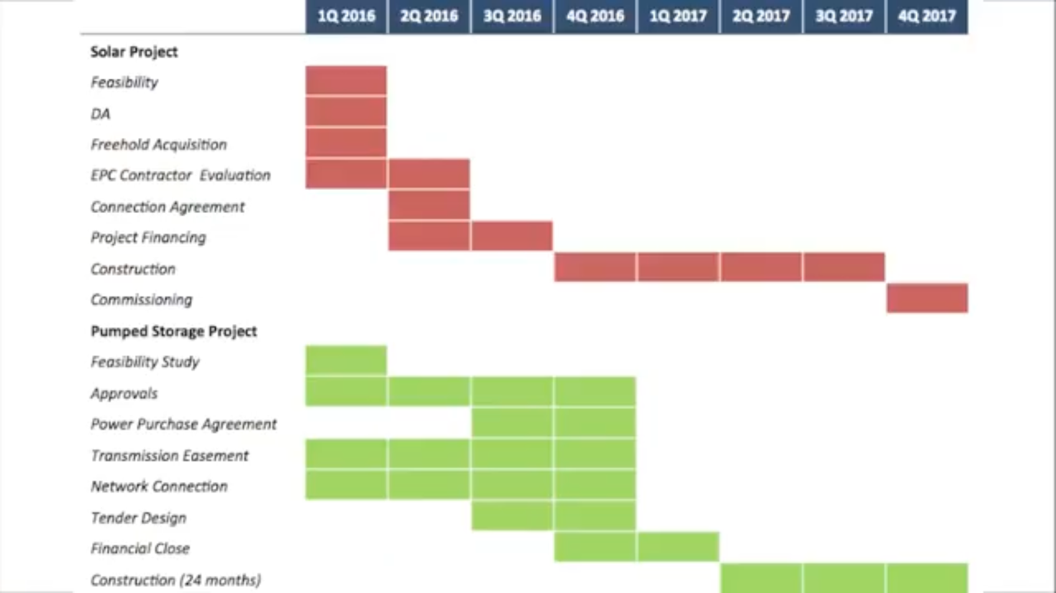

*Revised Gantt Chart (Genex Power, 2016)*

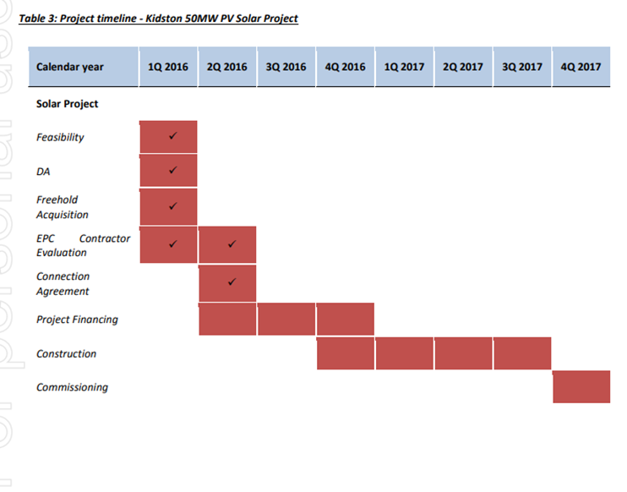

**APPENDIX B: Engineering drawings of the proposed project site (Genex, 2015)**

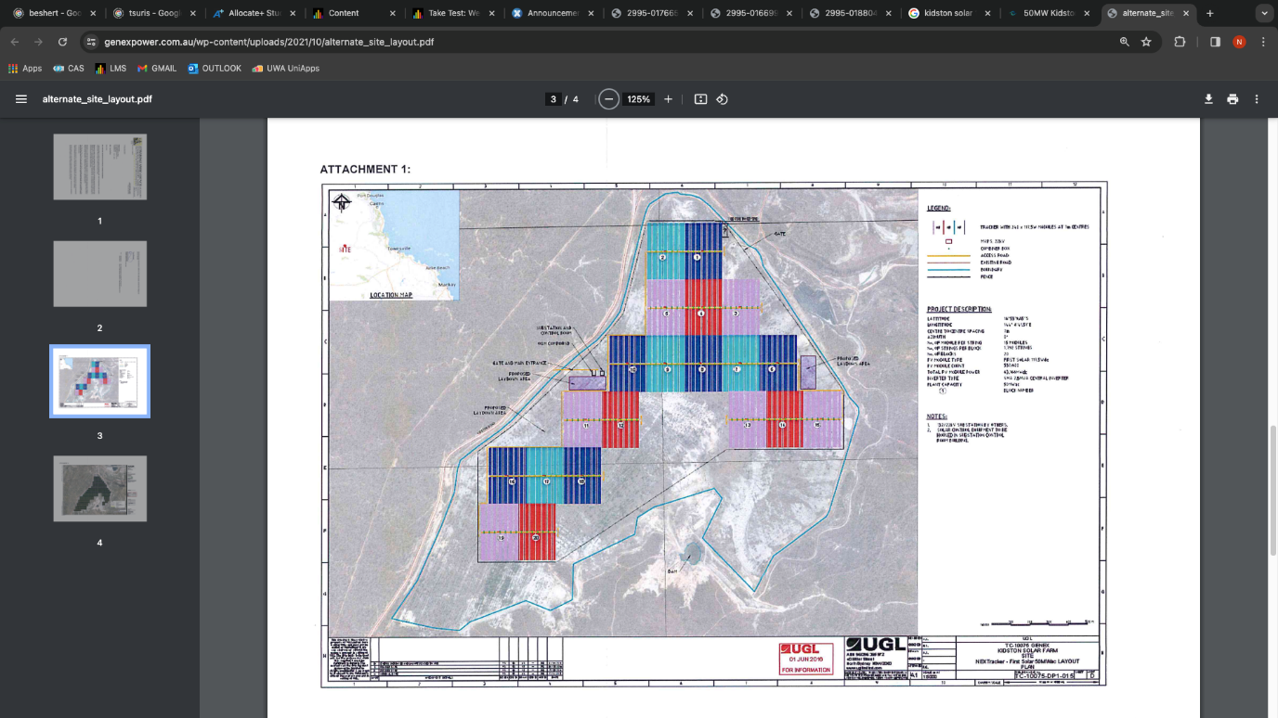

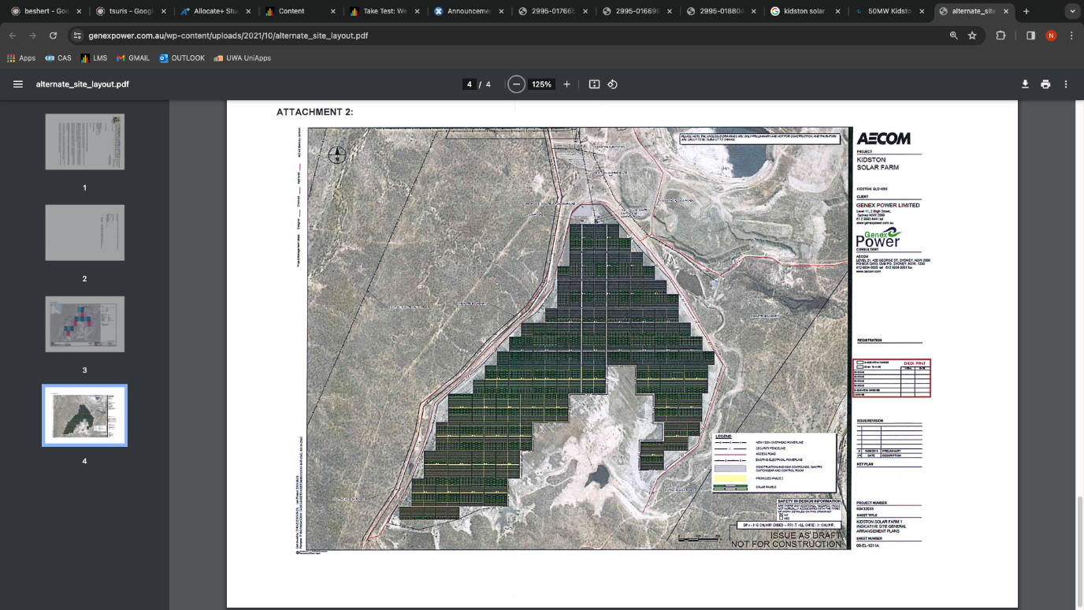

**APPENDIX C: Locational Advantages:**

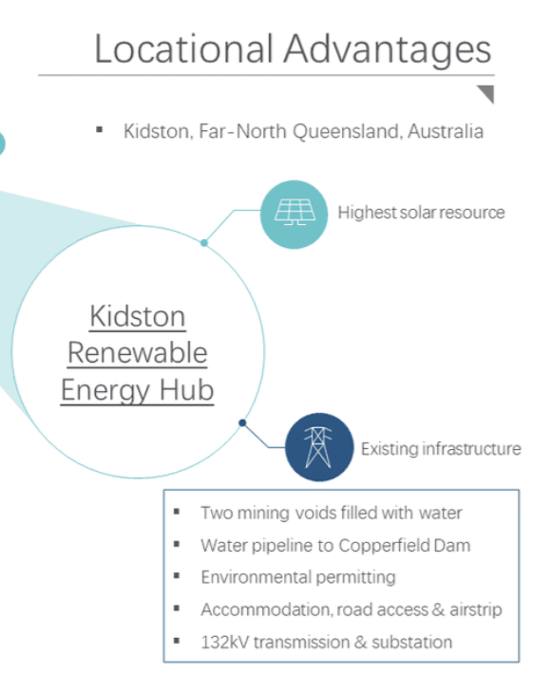

**APPENDIX D: Example figures extracted from Genex ASX announcements on the construction progress for KS1 (Genex, 2016)**

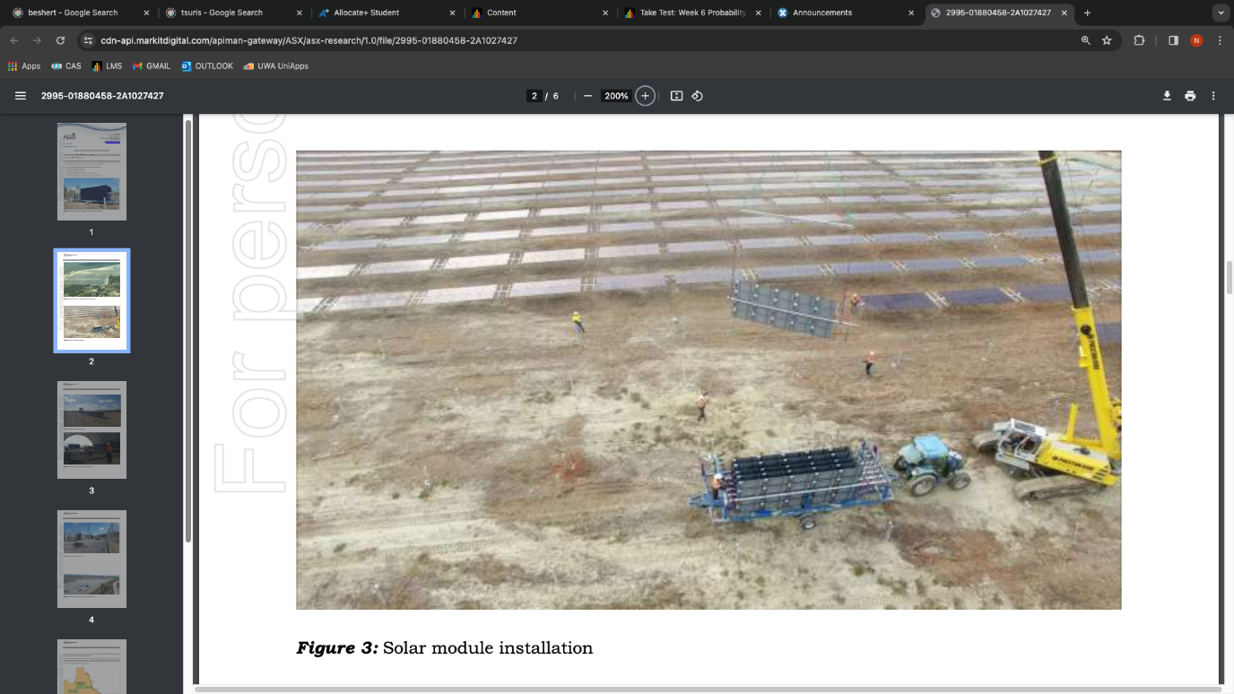

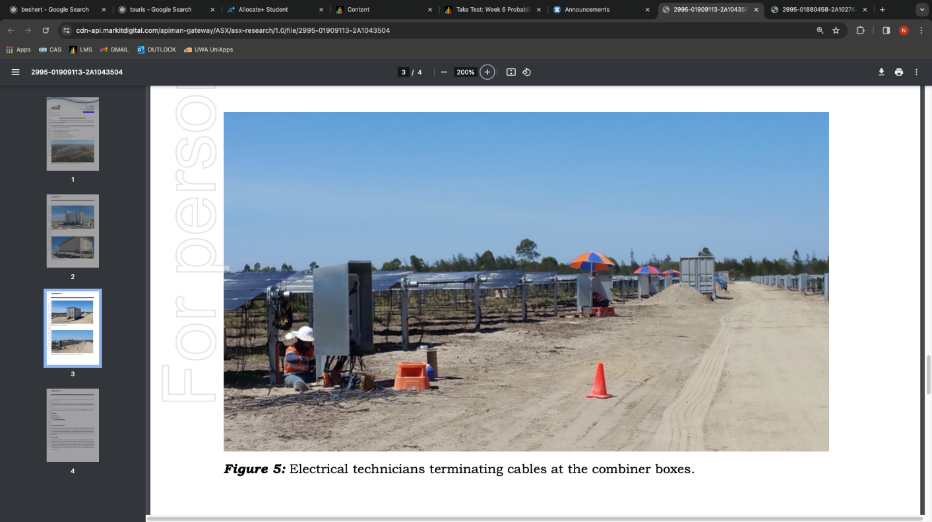

**Appendix E: Recommended Risk Register**

|  |  |  |  |  |  |  |
| --- | --- | --- | --- | --- | --- | --- |
| ***Risk Description*** | ***Probability*** | ***Impact*** | ***Priority*** | ***Strategy*** | ***Accountability*** | ***Control*** |
| *Unforeseen adverse movements in foreign exchange rates* | *High* | *High* | *High* | *Implement advanced hedging mechanisms such as options and forwards to mitigate currency exchange rate risks.* | *Project Finance Team* | *Monitor currency exchange rates continuously* |
| *A shortfall in required capital due to currency fluctuations* | *Medium* | *High* | *Medium* | *Conduct a thorough review of the project's financial model and incorporate contingency plans for fluctuations.* | *Finance Department* | *Continuous monitoring of project financials* |
| *Perception of failure in project planning or risk management* | *Medium* | *High* | *Medium* | *Improve communication with stakeholders, providing transparent updates on the project's financial status.* | *Project Management* | *Regular stakeholder updates and progress reports* |
| *Dependence on a single currency or geographic region* | *Medium* | *Medium* | *Medium* | *Explore opportunities to diversify the supplier base to reduce dependence and minimize exposure to fluctuations.* | *Procurement Team* | *Diversification of suppliers and markets* |
| *Inadequate monitoring of currency exchange rates* | *High* | *Medium* | *High* | *Establish a robust monitoring and reporting system to track currency rates continuously and adjust strategies.* | *Project Finance Team* | *Implement automated tracking and reporting mechanisms* |
| *Lack of long-term strategic planning for market dynamics* | High | *High* | *Low* | *Develop a comprehensive long-term strategic plan that incorporates potential risks and uncertainties.* | *Project Management* | *Periodic review and update of strategic plan* |

**Appendix F: Kidston connection project - proposed future connection by AECOM:**

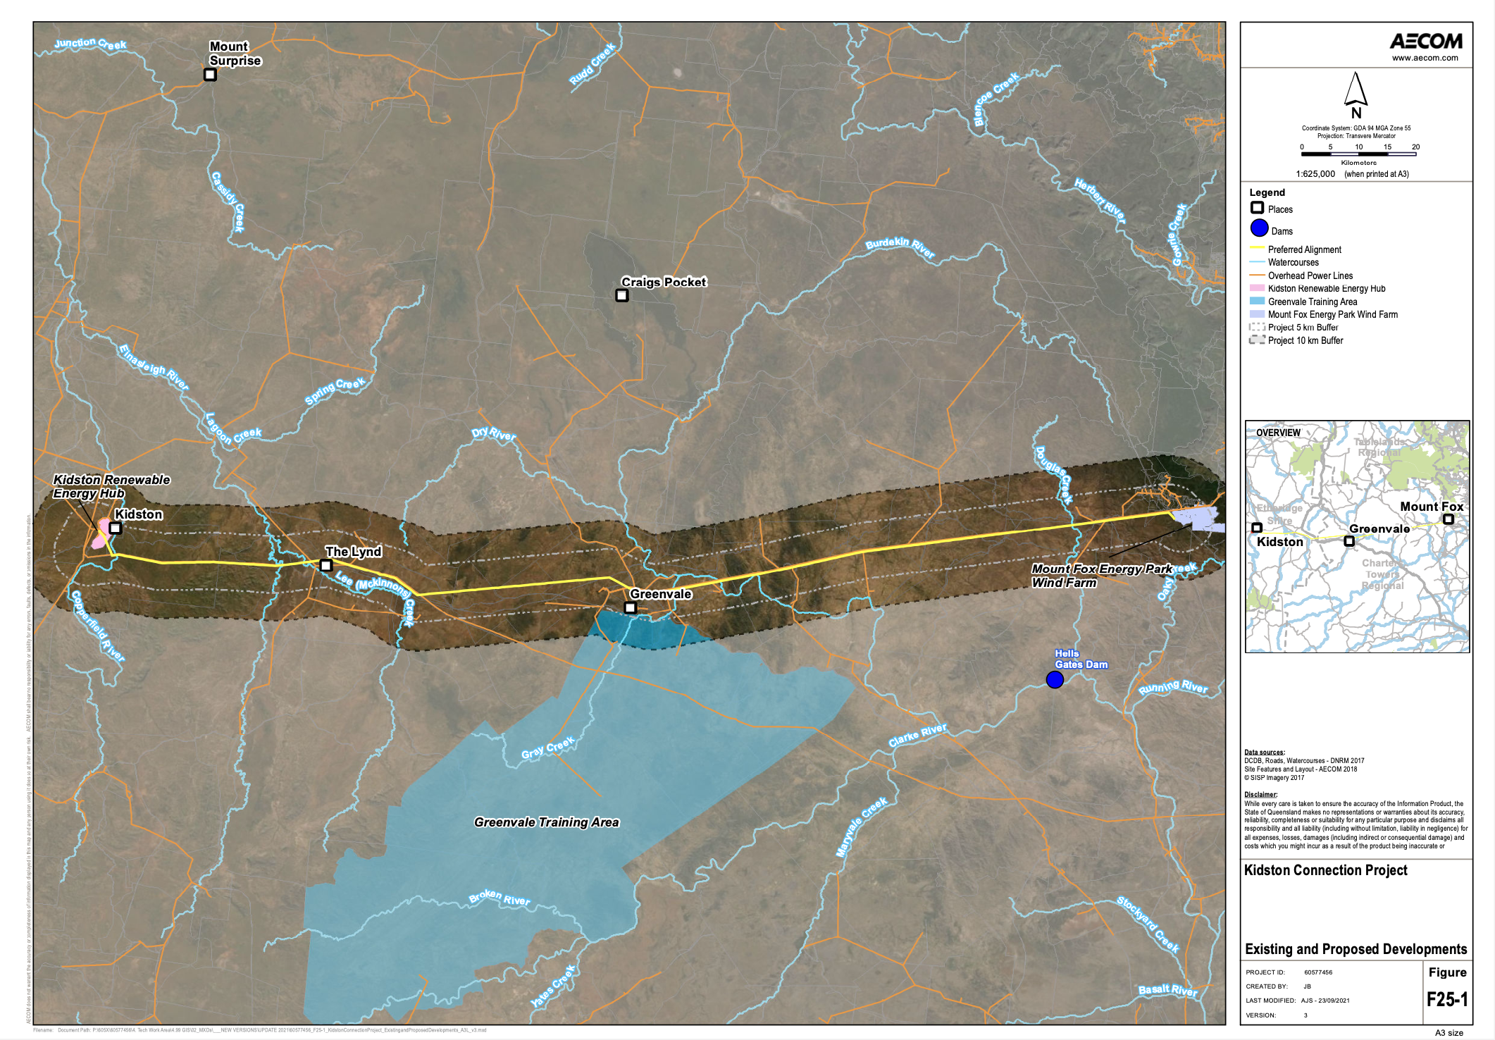

# 8. MEETING MINUTES & TEAM REFLECTIONS

**MEETING 1 MINUTES**

|  |  |
| --- | --- |
| **Date of Meeting: 29/02/2024** | **Location: Ezone Central Ground Floor**  **Chair: Nick Duplex** |
| **Minutes Prepared By:**  **Tatenda Makova** |  |
| **1. Purpose of Meeting**  Team members to become acquainted with each other and discuss the project. | |

|  |  |  |  |
| --- | --- | --- | --- |
| **2. Attendance at Meeting** | | | |
| *Name* |  | *Minutes Approval* |  |
| Rachel |  | YES |  |
| Tatenda |  | YES |  |
| Mick |  | YES |  |
| Nick |  | YES |  |

|  |
| --- |
| **3. Meeting Agenda** |
| Each member introducing themselves and what they are studying. |
| Discuss appropriate time for weekly meetings when everyone can be available and form of communication. |
| Proposing project ideas for any team members with any ideas |

|  |
| --- |
| **4. Meeting Notes, Decisions, Issues** |
| Group consists of member studying different fields and from different backgrounds |
| Thursday time selected for this week resulted in low attendance |
| 2 group chats, one on Facebook and one on Microsoft Teams however both do not have all team members in them. |
| Some project ideas presented to the team by Nick, Rachel and Tatenda. |

 Selected new meeting time weekly on Tuesdays at 2pm

|  |  |  |  |
| --- | --- | --- | --- |
| **5. Action Items** | | | |
| *Action* |  | *Due Date* | *Status* |
| Create 1 Microsoft Teams group chat which will be the medium of all communication. |  | 29/02/2024 | Complete |
| Continue researching and brainstorming topics for the report to present at the next meeting |  | 05/03/2024 | In Progress |
| Inform absent group members of meeting time via the new group chat |  | 29/02/2024 | Complete |

|  |  |  |  |  |  |  |
| --- | --- | --- | --- | --- | --- | --- |
| **6. Next Meeting** | | | | | | |
| *Date:* | | 05/03/2024 | *Time:* | 2PM | *Location:* | Ezone |
| *Agenda:* | Selected a project topic and send it to Cosi | | | | | |

**Post Meeting Team Reflection**

As this was the first meeting, group members were familiarising themselves with each other and getting to know each other and what they do. The meeting was intended to be a kick off meeting for the project but with less than half attendance it was noticeable that the selected time was not suitable for most group members. This highlighted the issue we had, having created a Facebook group chat with all those who attended the first practical class on Tuesday and only emailing those who did not attend. Thus, those who were not in the Facebook group did not know about the meeting. This issue was quickly resolved by creating a Microsoft Teams chat which everyone would have access to for the rest of the project. Of those who attended, there was good respect for each other, and communication was effective, giving each other the task and responsibilities of finding a project to research.

**MEETING 2 MINUTES**

|  |  |
| --- | --- |
| **Date of Meeting: 05/03/2024** | **Location: Ezone North Meeting Room 203**  **Chair: *Tatenda Makova*** |
| **Minutes Prepared By:**  **Mick Luu** |  |
| **1. Purpose of Meeting**  To assign group members with different topics of the report to research. | |

|  |  |  |  |
| --- | --- | --- | --- |
| **2. Attendance at Meeting** | | | |
| *Name* |  | *Minutes Approval* |  |
| Rachel Tausem |  | YES |  |
| Pritam Suwal Shrestha |  | YES |  |
| Ninu Latheesh |  | YES |  |
| Tatenda Makova |  | YES |  |
| Mick Luu |  | YES |  |
| Ken Ji |  | YES |  |
| Nick Duplex |  | YES |  |

|  |
| --- |
| **3. Meeting Agenda** |
| Review the list of projects from a list constructed based on the research done by each individual member. |
| Discuss and alter the list according to the group members’ preferences and reasoning for each project and narrow down the list to a small list of projects. |
| Construct a finalised ranking of projects preferred for our group project and send the email of to Professor Cosimo Faiello |

|  |
| --- |
| **4. Meeting Notes, Decisions, Issues** |
| It was found that we had a big range of projects which we had to narrow down to a couple of projects which we thought as a group would be most suited to the criteria of this project. |
| The group had to decide on a list of projects to send off to Pro Cosimo Faiello to get approval before the commencement of research for the project. |

|  |  |  |  |
| --- | --- | --- | --- |
| **5. Action Items** | | | |
| *Action* |  | *Due Date* | *Status* |
| Continue researching and brainstorming topics for the report to present at the next meeting |  | 05/03/2024 | Complete |
| Sections to be split up for research once approval from Professor Cosimo Faiello has been emailed |  | 12/03/24 | Not Complete |

|  |  |  |  |  |  |  |
| --- | --- | --- | --- | --- | --- | --- |
| **6. Next Meeting** | | | | | | |
| *Date:  12/03/2023* | |  | *Time:* | *2pm* | *Location:* | *Ezone North Room 203* |
| *Agenda:* | **Splitting research for stakeholders and assigned topics to be discussed in next meeting.** | | | | | |

**Post Meeting Group Reflection**

Overall, this group meeting had some agreements and disagreements in the project discussed. Nick showed great leadership in guiding the group throughout each of our project choices and helped the group come to a cohesive agreement for a finalised list.  The group was starting to get more comfortable with each other than before, as we were missing group members in our previous introduction meeting within the practical class. In addition, Tatenda controlled the meeting quite well by exploring all options for the project whilst conducting a voting system to narrow down our list.

**MEETING 3 MINUTES**

|  |  |
| --- | --- |
| **Date of Meeting:** 12/03/2024 | **Location:** Ezone North Meeting Room 203  **Chair: Rachel Tausem** |
| **Minutes Prepared By:***Nick Duplex* |  |
| **1. Purpose of Meeting** *(add rows as necessary under banner headings)*  Review and discuss research on newly selected project – Kidston Solar Farm | |

|  |  |  |  |
| --- | --- | --- | --- |
| **2. Attendance at Meeting** | | | |
| *Name* |  | *Minutes Approval* |  |
| Rachel Tausem |  | YES |  |
| Pritam Suwal Shrestha |  | YES |  |
| Ninu  Latheesh |  | YES |  |
| Tatenda Makova |  | YES |  |
| Mick Luu |  | YES |  |
| Ken Ji |  | YES |  |
| Nick Duplex |  | YES |  |
| **3. Meeting Agenda** | | | | |
| Attempt to reach out to a stakeholders at FMG involved with the Iron Bridge Project | | | | |
| Conversion on the general requirements of the report | | | | |
| Assign each member of the group a project management competency to guide their research into the selected project | | | | |

|  |  |  |  |
| --- | --- | --- | --- |
| **4. Meeting Notes, Decisions, Issues** | | | |
| An emailed was drafted to a potential contact at FMG that a group member had mutual associate with. As a group the email was approved and sent. | | | |
| Through group discussion analysing the provided information from lectures and practical classes, it became apparent that the report would heavily rely on discussion of the project management competencies. | | | |
| The ten competencies were to be divided amongst group members for the purposes of research. | | | |
| A shared Google-Doc was created so that the groups research could be combined simply in one place. | | | |
|  | | | |
| **5. Action Items** | | |
| *Action* | *Due Date* | *Status* |
| Group members would research the project management competencies for the Iron Bridge Project | 19/04/24 | In Progress |
|  |  |  |
|  |  |  |

|  |  |  |  |  |  |  |
| --- | --- | --- | --- | --- | --- | --- |
| **6. Next Meeting** | | | | | | |
| *Date:* | | 19/03/24 | *Time:* | 11AM | *Location:* | Ezone North Meeting Room 203 |
| *Agenda:* | Discuss the findings of the research over the previous week | | | | | |

**Post Meeting Team Reflection**

This meeting was productive as we achieved the objective of reaching out to a stakeholder of the project. The team also felt imbued with a new sense of direction from the previous week as with now more clear assigned individual goals for the week to follow we could be more confident that our efforts would contribute directly to the overall project goals.

Group cohesiveness also had noticeable development after this meeting as members demonstrated more openness to contribute to discussion and ready willingness to adopt responsibilities relating to the report. A group identity was more clearly starting to reveal itelf.

**MEETING 4 MINUTES**

|  |  |
| --- | --- |
| **Date of Meeting: 19/03/2024** | **Location: Ezone North Meeting Room 203**  **Chair: Pritam Suwal Shrestha** |
| **Minutes Prepared By: Ken Ji** |  |
| **1. Purpose of Meeting**  Discussing competencies and didn’t find adequate information, decided to look for new project | |

|  |  |  |  |
| --- | --- | --- | --- |
| **2. Attendance at Meeting** | | | |
| *Name* |  | *Minutes Approval* |  |
| Rachel Tausem |  | YES |  |
| Pritam Suwal Shrestha |  | YES |  |
| Ninu Latheesh |  | YES |  |
| Tatenda Makova |  | YES |  |
| Mick Luu |  | YES |  |
| Ken Ji |  | YES |  |
| Nick Duplex |  | YES |  |
| **3. Meeting Agenda** | | | | |
| Discussing competencies and didn’t find adequate information, decided to look for new project. | | | | |
| Nick and Mick were assigned to find new projects and company contact points. | | | | |
| Plan for an additional Saturday meeting before the weekly Tuesday meeting. | | | | |

|  |  |  |  |
| --- | --- | --- | --- |
| **4. Meeting Notes, Decisions, Issues** | | | |
| Each team member presented their findings on their selected project management competencies and discussed what information they are missing. | | | |
| As a team we reviewed the list of missing information and the difficulty of reaching out to company contacts. | | | |
| Discussing competencies and didn’t find adequate information, decided to look for new projects. | | | |
| Decided to have all our potential project found by Saturday so we can propose a new project for next week. | | | |
| Tatenda attempt to reach out to FMG Company project contact for the very last time. | | | |
| Decided to meet on Saturday 23/03 to confirm new projects findings. | | | |
| A email was sent to Professor Cosimo Faiello to update him on our progress and seek assistance with the challenges we faced. | | | |
|  | | | |
| **5. Action Items** | | |
| *Action* | *Due Date* | *Status* |
| Group members to research the project management competencies for the Iron Bridge Project | 19/04/24 | Done | |
| Mick was assigned to find new projects and Western power company contacting point. | 22/03/24 | Not Complete |
| Nick was assigned to find new projects and company contacting point. | 22/03/24 | Not Complete |
| Email Professor Cosimo Faiello to report project information gathering and contact point issues, also seeking for help | 21/03/24 | In Progress |

|  |  |  |  |  |  |  |
| --- | --- | --- | --- | --- | --- | --- |
| **6. Next Meeting** | | | | | | |
| *Date:* | | 23/03/24 | *Time:* | 11AM | *Location:* | Online (MS Teams) |
| *Agenda:* | New project proposal | | | | | |

**Post Meeting Team Reflection**

After our meeting, the team took some time to reflect on our progress and decisions. We found the meeting productive in terms of identifying our challenges regarding project management competencies and acknowledging the inadequacy of information available. This realisation prompted us to pivot towards searching for new project opportunities.

Each team member contributed by presenting their findings and expressing their concerns about the missing information. It was clear that reaching out to company contacts posed a significant obstacle. Despite the challenges, we kept a proactive attitude and decided to allocate specific tasks to expedite the process. Mick and Nick were tasked with finding new projects and corresponding company contacts.

We decided to schedule an additional meeting in 4 days to finalise our project selections. In our reflection, we recognised the importance of effective communication and collaboration. Although some tasks were still in progress, we were confident in our ability to overcome obstacles collectively. Looking ahead, we push strong for a new project and move forward with our group project with renewed energy and focus.

**MEETING 5 MINUTES**

|  |  |
| --- | --- |
| **Date of Meeting: 23/03/2024** | **Location: Teams Online Meeting**  **Chair: Nick Duplex** |
| **Minutes Prepared By: Ken Ji** |  |
| **1. Purpose of Meeting**  Found new project and reallocated roles, reached out to company | |

|  |  |  |  |
| --- | --- | --- | --- |
| **2. Attendance at Meeting** | | | |
| *Name* |  | *Minutes Approval* |  |
| Rachel Tausem |  | YES |  |
| Pritam Suwal Shrestha |  | YES |  |
| Tatenda Makova |  | YES |  |
| Mick Luu |  | YES |  |
| Ken Ji |  | YES |  |
| Nick Duplex |  | YES |  |
| **3. Meeting Agenda** | | | | |
| Nick presented newly found project Kidston Solar Farm (Phase 1) | | | | |
| Ken assigned to reach out to the Co-director of the coach company Genex power | | | | |
| Plan project report structure | | | | |

|  |  |  |  |
| --- | --- | --- | --- |
| **4. Meeting Notes, Decisions, Issues** | | | |
|  | | | |
| Everyone to present their newly found projects | | | |
| Nick presented his findings on a new project Kidston Solar Farm (Phase 1) project | | | |
| As a team we reviewed this found projects and conduct an evaluation of if this new project | | | |
| Ken was assigned reach out to the Ben Guo (Genex Contact) for his willingness of providing information to support our research study | | | |
| An email was sent to the project management unit coordinator for approval of the chosen project | | | |
| **5. Action Items** | | |
| *Action* | *Due Date* | *Status* |
| Mick was assigned to find new projects and Western power company contacting point. | 22/03/24 | Complete | |
| Nick was assigned to find new projects and company contacting point. | 22/03/24 | Complete | |
| Email Professor Cosimo Faiello to report project information gathering and contact point issues, also seeking for help | 21/03/24 | Complete | |
| Start research for project management competencies for Kidston Solar Farm (Phase 1) Project | 23/04/24 | In Progress |
| Contact Ben Guo and organise a teams meeting for Tuesday 02/04 | 23/03/24 | In Progress |
| Email Professor Cosimo Faiello for project approval | 23/04/24 | In Progress |

|  |  |  |  |  |  |  |
| --- | --- | --- | --- | --- | --- | --- |
| **6. Next Meeting** | | | | | | |
| *Date:* | | 26/03/24 | *Time:* | 2PM | *Location:* | Ezone |
| *Agenda:* | Weekly Tuesday meeting | | | | | |

**Post Meeting Team Reflection**

Following our team meeting, the group took some time to reflect on the progress made and decisions taken. The meeting served its purpose of finding a new project and reallocating roles effectively. Despite the unsuccessful attempts to contact both FMG and western power. The team managed to move forward with the agenda. Nick presented the newly discovered project, Kidston Solar Farm (Phase 1), which was met with interest from the rest of the team. We collectively reviewed all the proposed projects and conducted an evaluation, concluding that Kidston Solar Farm (Phase 1) provided the most comprehensive information online, making it the most suitable choice for our group project.

In our reflection, we acknowledged the importance of adaptability and efficiency in addressing unexpected challenges. The team maintained focus and successfully achieved our objectives for the meeting. Looking ahead for our weekly Tuesday meeting to further progress our project and ensure we remain on track to meet our goals.

**MEETING 6 MINUTES**

|  |  |
| --- | --- |
| **Date of Meeting: 26/03/2024** | **Location: Ezone North Meeting Room 203**  **Chair: Mick Luu** |
| **Minutes Prepared By: Rachel Tausem** |  |
| **1. Purpose of Meeting**  Review and discuss research on newly selected project – Kidston Solar Farm | |

|  |  |  |  |
| --- | --- | --- | --- |
| **2. Attendance at Meeting** | | | |
| *Name* |  | *Minutes Approval* |  |
| Rachel Tausem |  | YES |  |
| Pritam Suwal Shrestha |  | YES |  |
| Ninu Latheesh |  | YES |  |
| Tatenda Makova |  | YES |  |
| Mick Luu |  | YES |  |
| Ken Ji |  | YES |  |
| Nick Duplex |  | YES |  |
| **3. Meeting Agenda** | | | | |
| Review research done on the Kidston Solar Farm (Phase 1) relating to the project management competencies | | | | |
| Discuss research findings and start creating a list of questions to ask Ben Guo (Genex Contact) | | | | |
| Plan project report structure | | | | |

|  |  |  |  |
| --- | --- | --- | --- |
| **4. Meeting Notes, Decisions, Issues** | | | |
| Each team member presented their findings on their selected project management competencies and discussed what information they are missing, including questions to ask Ben. | | | |
| As a team we reviewed the list of questions and wrote it up on the shared word document. We decided if anyone has any more questions, that they would write it in the document prior to our meeting with Ben. | | | |
| Decided on a MS teams meeting with Ben on Tuesday 02/04. Ken will be contacting Ben to see if he is available and ask if Ben has any project documents he can send through for us. | | | |
| Decided to have all our research done by Tuesday so we know what information we need from Ben. | | | |
| Decided to meet on Thursday 04/04 to write the report together. | | | |
| Discussed which project management competencies are most relevant to each stage of the project life cycle for Part B of the report. | | | |
| Decided on the project management competencies for each project lifecycle and wrote up the contents page of the report as a guide. | | | |
| **5. Action Items** | | |
| *Action* | *Due Date* | *Status* |
| Start research for project management competencies for Kidston Solar Farm (Phase 1) Project | 23/04/24 | Complete | |
| Email Professor Cosimo Faiello for project approval | 23/04/24 | In Progress | |
| Finalise research for project management competencies for Kidston Solar Farm (Phase 1) project | 02/04/24 | In Progress |
| Contact Ben Guo and organise a teams meeting for Tuesday 02/04 | 29/03/24 | Not complete |
| Start writing the report | 04/04/24 | In Progress |

|  |  |  |  |  |  |  |
| --- | --- | --- | --- | --- | --- | --- |
| **6. Next Meeting** | | | | | | |
| *Date:* | | 02/04/24 | *Time:* | 11AM | *Location:* | Online (MS Teams) |
| *Agenda:* | Interview with Ben Guo. | | | | | |

**Post Meeting Team Reflection**

The team felt this meeting was productive as we achieved all our objectives. We feel more confident with the amount of research and information available online for the new project. We have identified we are now in the performing stage of team development. Every team member had completed their research on time which enabled thorough group discussion on any missing information. When deciding which project management competencies are most relevant for each of the life cycle stages, there was some disagreement. However, after sharing our reasonings, perspectives and reviewing the textbook we were able to come to a mutual agreement. We were also open, as a team, to make any changes later if deemed necessary. Furthermore, we have highlighted that a lot of time was wasted thinking about questions to ask Ben Guo. After 15 minutes we decided if anyone had any more questions, that they would write it in the document prior to our meeting with Ben. This time did not feel productive compared to the rest of the meeting as there was a lot of silence and a lack of discussion. We feel the decision to individually write your questions in the shared document should have been decided quicker to make the meeting more efficient and engaging. This will be implemented in the next meeting to avoid long stints of lowered productivity and avoid a decrease in engagement from team members.

**MEETING 7 MINUTES**

|  |  |
| --- | --- |
| **Date of Meeting: 05/04/2024** | **Location: Ezone North Meeting Room 203**  **Chair: Ninu Latheesh** |
| **Minutes Prepared By: Pritam Suwal Shrestha** |  |
| **1. Purpose of Meeting**  Review report content and finalise missing information | |

|  |  |  |  |
| --- | --- | --- | --- |
| **2. Attendance at Meeting** | | | |
| *Name* |  | *Minutes Approval* | |
| Rachel Tausem |  | YES | |
| Pritam Suwal Shrestha |  | YES | |
| Ninu Latheesh |  | YES | |
| Tatenda Makova |  | YES | |
| Mick Luu |  | YES | |
| Ken Ji |  | YES | |
| Nick Duplex |  | YES | |
| **3. Meeting Agenda** | | |
| Schedule Interview with Ben Guo | | |
| Discuss the content of project lifecycle stages | | |
| Add each independent competency on shared Project file to follow project structure | | |

|  |  |  |  |
| --- | --- | --- | --- |
| **4. Meeting Notes, Decisions, Issues** | | | |
| Each team member presented their content on respective competencies and discussed potential additions or removals. We will proofread to eliminate redundant information. | | | |
| Ben Guo (KS1 contact) responded to our meeting request and confirmed that the meeting will take place on April 5th at 1 pm. | | | |
| The team decided to follow APA reference style for referencing due to its widely recognized standardization and credibility within academic and professional circles. | | | |
| The team decided that each member will individually record their presentation on their respective slides, and these recordings will be stitched together for submission. | | | |
| Slides will be created after the completion of the report by Tuesday, April 9th, 2024. | | | |
| Discussed the incorporation of the Triple Bottom Line in the report and emphasized the need to justify the project's purpose. | | | |
| The interview questions with Ben Guo have been finalized. Suggested asking Ben about the proposal document to gather additional information on risk assessment and related topics, if possible, for further insight. | | | |
| Requested the source for the Work Breakdown Strategy from a team member. | | | |
| **5. Action Items** | | |
| *Action* | *Due Date* | *Status* |
| Email Professor Cosimo Faiello for project approval | 23/04/24 | Complete | |
| Finalise research for project management competencies for Kidston Solar Farm (Phase 1) project | 02/04/24 | Complete | |
| Contact Ben Guo and organise a teams meeting for Tuesday 02/04 | 29/03/24 | Complete | |
| Start writing the report | 04/04/24 | Complete |
| Interview of Ben Guo | 05/04/24 | Not Complete |
|  |  |  |

|  |  |  |  |  |  |  |
| --- | --- | --- | --- | --- | --- | --- |
| **6. Next Meeting** | | | | | | |
| *Date:* | | 02/04/24 | *Time:* | 11AM | *Location:* | Online (MS Teams) |
| *Agenda:* | * Add references to the project report following APA Format * Create slides for presentation | | | | | |

**Post Meeting Team Reflection**

In our recent meeting, we observed significant progress in project discussions and individual competency presentations. However, upon reflection, we recognize that while each team member effectively presented their respective competencies, there was a notable lack of cross-engagement with others' areas of expertise. This led to some topics being duplicated and prolonged explanations of what occurred within each competency. Looking ahead, we see the importance of working together better by understanding each other's parts of the project. To improve, we will share ideas and feedback more during our meetings. One way we'll do this is by having team members look at each other's work before we meet, so we can avoid repeating things and understand the project better. Additionally, while our meeting achieved its primary objective of reviewing individual competencies and scheduling an interview with Ben Guo, we acknowledge that we could have managed our time more efficiently. Some discussions could have been more organized, making decisions clearer and quicker. To fix this for our next meeting, we'll be stricter with time. We'll set specific limits for each agenda item and have someone keep track to make sure we stick to the schedule. Plus, we'll encourage everyone to keep their contributions short and to the point, which should help us have smoother discussions and make decisions faster.

**MEETING 8 MINUTES**

|  |  |
| --- | --- |
| **Date of Meeting: 09/04/2024**  **Minutes Prepared By:**  **Ninu Latheesh** | **Location: Ezone North Meeting Room 203**  **Chair: Ken Ji** |
| **1. Purpose of Meeting**  To review, discuss, and enhance the project report on the Kidston Solar project Phase 1. | |

|  |  |  |  |
| --- | --- | --- | --- |
| **2. Attendance at Meeting** | | | |
| *Name* |  | *Minutes Approval* |  |
| Rachel Tausem |  | YES |  |
| Pritam Suwal Shrestha |  | YES |  |
| Ninu Latheesh |  | YES |  |
| Tatenda Makova |  | YES |  |
| Mick Luu |  | YES |  |
| Ken Ji |  | YES |  |
| Nick Duplex |  | YES |  |
| **3. Meeting Agenda** | | | | |
| Comprehensive review of the current project report. | | | | |
| Glorification and refinement of the report based on collective insights. | | | | |
| Distribution of tasks for the completion of the report. | | | | |

|  |  |  |  |
| --- | --- | --- | --- |
| **4. Meeting Notes, Decisions, Issues** | | | |
| The team collectively reviewed the project report, focusing on integrating individual contributions into a cohesive document. Every sentence was scrutinized for accuracy, relevance, and impact to ensure the report's quality. | | | |
| Following the review, the team identified areas needing additional work and decided to distribute tasks among members to finalize the report. | | | |
| A significant concern was the report's word count, which exceeded the requirement. Strategies for culling unnecessary content were discussed. | | | |
| Decided on a MS teams meeting on Wednesday 09/04. | | | |
|  | | | |
| **5. Action Items** | | |  |
| *Action* | *Due Date* | *Status* |  |
| Interview of Ben Guo | 05/04/24 | Complete |  |
| Finalize the Project Report | 12-04-2024 | In progress |  |
| Finish the distributed tasks | 10-04-2024 | In progress |  |

|  |  |  |  |  |  |  |
| --- | --- | --- | --- | --- | --- | --- |
| **6. Next Meeting** | | | | | | |
| *Date:* | | 10/04/24 | *Time:* | 8PM | *Location:* | Online (MS Teams) |
| *Agenda:* | Final touch-up for the report and report submission | | | | | |

**Post Meeting Team Reflection**

In our recent team meeting held on 09/04/2024, we collectively delved into the comprehensive review and refinement of our project report on the Kidston Solar Project Phase 1. This session was pivotal, enabling us to merge individual insights into a unified document that accurately reflects our research and analysis. The meticulous scrutiny of each sentence for its accuracy, relevance, and impact significantly elevated the quality of our report. Although we encountered a challenge with the report's word count exceeding our target, our discussions led to strategic decisions on content culling to meet requirements without compromising the report’s integrity. Additionally, the meeting’s outcome saw a redistribution of tasks to address areas needing further enhancement. Our decision to convene an MS Teams meeting on the following day underscores our commitment to the project's timely and efficient completion. This meeting not only solidified our teamwork and collaborative spirit but also marked a significant step towards our goal, leaving us more confident in our project's direction and our ability to meet the upcoming deadline.

**MEETING 9 MINUTES**

|  |  |
| --- | --- |
| **Date of Meeting: 14/04/2024** | **Location: MS Teams                                                      Chair: *Nick Duplex*** |
| **Minutes Prepared By:**  **Mick Luu** |  |
| **1. Purpose of Meeting**  Finalise group report and submission. | |

|  |  |  |  |
| --- | --- | --- | --- |
| **2. Attendance at Meeting** | | | |
| *Name* |  | *Minutes Approval* |  |
| Rachel Tausem |  | YES |  |
| Pritam Suwal Shrestha |  | YES |  |
| Ninu Latheesh |  | YES |  |
| Tatenda Makova |  | YES |  |
| Mick Luu |  | YES |  |
| Ken Ji |  | YES |  |
| Nick Duplex |  | YES |  |

|  |
| --- |
| **3. Meeting Agenda** |
| Proofread final submission as well as compiling all the meeting minutes, reflections, reports and appendices for submission. |
| Compiling the document with a signed coversheet and rubric as well. |
| Agreed upon the final submission and the report that has been submitted. |

|  |
| --- |
| **4. Meeting Notes, Decisions, Issues** |
| Everyone had a role of proofreading the documents from top to bottom to look out ofor spelling mistakes and making sure that the formatting was universal throughout the document. |
| Compiling both the meeting minutes, reflections and appendixes as well to be included in the report and make sure that they are referenced to the relevant sections in the report. |
| Getting everyone to sign the coversheet with their initials and attach a copy of the rubric at the front of the report for final submission. |
| Collectively agreed on the final report submission to LMS by our group leader Nick Duplex. |

|  |  |  |  |
| --- | --- | --- | --- |
| **5. Action Items** | | | |
| *Action* |  | *Due Date* | *Status* |
| Finalize the Project Report |  | 12/04/24 | Completed |
| Finish the distributed tasks |  | 10/04/24 | Completed |
| Group report finalisation and submission. |  | 14/04/24 | Completed |

|  |  |  |  |  |  |  |
| --- | --- | --- | --- | --- | --- | --- |
| **6. Next Meeting** | | | | | | |
| *Date:* | | None | *Time:* | - | *Location:* | - |
| *Agenda:* | - | | | | | |

**Post Meeting Team Reflection**

Overall, the group meeting went smoothly as usual which was due to many factors such as our chemistry as a group being very good and understanding of each of our strengths and weaknesses. The group meeting started with Nick leading us again in what tasks each group member is assigned to do to make sure that the group report is ready for its final submission and filling in the gaps if required. Everyone in the group, had met all their requirements of the group to be able to construct a group report altogether and had worked around challenges to fit everyone’s needs. Consequently, to get this task done, Nick who was our group leader had given certain deadlines for each of our tasks which ran smoothly as he would regularly check up on each of us to make sure we were alright with our section and if not then he would be able to assist in us understanding the task which is meant to be done.

**Final Team Reflection**

The group worked cohesively as a team to complete the assignment by the due date and time. Issues that were encountered in the group were regarding communication, busy schedules, and pressures of other units.

Having 7 group members of different cultural backgrounds and studying different courses was a hurdle the group faced in regards to communication. However, we were able to overcome this by respectfully communicating with each other. Every member’s opinion was valued and respected and everyone listened whenever someone was speaking. This meant that all members had the confidence to bring up bright ideas needed for the progression of the project. In addition to this, there was conflict of ideas regarding certain topics, but this was good for the team as it did not go overboard and we challenged each other which resulted in even better outcomes for the team.

Another issue was finding a meeting time that was suitable for all members due to the busy timetables of Masters students. The group overcame this by members submitting their available windows of time on campus for a meeting onto an online software called ‘When2meet’. This software took all the input data and produced the best time which suited the majority of group members, and this was the time we decided to use (Tuesday’s at 2pm). The progression in attendance can be seen from how in week 1 we had 3 members at the meeting and in contrast the last 4 meetings having at least 6 members present.

Team members showed great accountability with all members doing their allocated and respective parts to the best of their abilities. Members went above and beyond, working extra hours and weekends since we fell behind having been unable to utilise the first Project we had selected. Time management was excellent, and all milestones were reached at the planned times. All members were punctual, arriving to meetings on time and notifying the group if unable to attend.

Overall, the teamwork was strong and it was a valuable experience for all members involved where we further developed our teamwork, research, report writing and project management skills and it aided all members in their studies of this unit, hence being a fulfilling and enjoyable project.